Case 6-Afr-Sierra Leone-Mende people-Nomoli-Mother and Child-Steatite-13th century

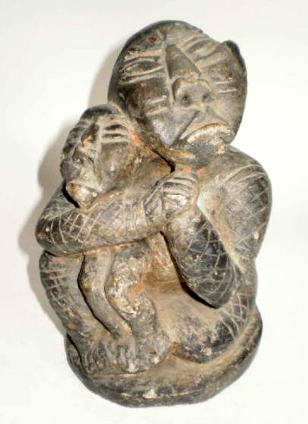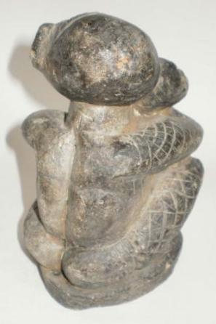
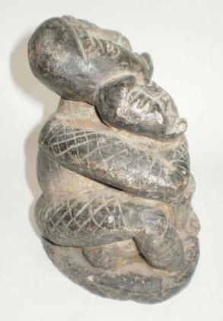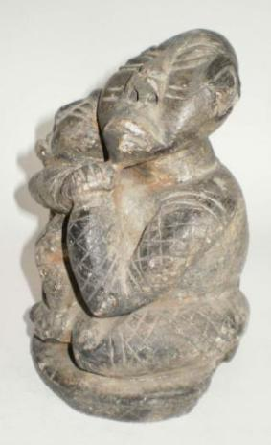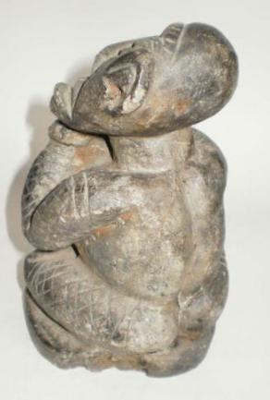
Figs 1-5. Afr-Sierra Leone-Mende people-Nomoli-Mother and Child-Steatite-13th century

Case no.: 6
Accession Number:
Formal Label: Afr-Sierra Leone-Mende people-Nomoli-Mother and Child-Steatite-13th century
Display Description:
"Mother and Child" - Rare Old Sierra Leone Soapstone Statue, Nomoli - Kissi, expressive countenance. Carved out of steatite (midi),
The occurrence of nomoli is restricted to a comparatively small area, about 20 km to 40 km from the coast between the Boomn and Kittam Rivers. The Kittam River is very slow moving, since the headwaters are only about one meter asl, as it is formed at the confluence of the Sewa and Waanje rivers about 5 km from the Atlantic coast. It follows this parallel 48 km in a NW direction until it reaches the large Sherbro River estuary just east of Sherbroya. Along the way there are lagoons and small streams, and the lowlands are often flooded during the rainy season.
Nomoli steatite sculptures which are among sole examples of stone carving in West Africa date as early as ca 8th c. In the 16th c the first European explorers named their sculptors ‘Sapes,’ but their identity is unknown. The ritual use of the nomoli was first indicated in a letter written by Antonio Malfante and addressed to Giovanni Mariono in 1447: "To the south … are ... territories, the inhabitants of which are all blacks and idolators, continually at war with each other in defense of their law and faith of their idols. Some worship ... groves of trees, the seats of a spirit to whom they make sacrifice; others again, statues of wood and stone, with which, they say, they commune by incantations” (Crone 1937: 87-88). The “groves of trees” to which Malfante makes reference here are undoubtedly the “bushes” of the secret societies so common in this part of West Africa.
The natives, knowing nothing of the nomoli, explain their existence by attributing to them a supernatural origin of great value and finders keep their nomoli locations secret. When they are found on agricultural fields they are considered effective charms for dry-rice crops, so the Mende and others make offerings to the nomoli to help in rice farming (Atherton and Kalous 2009).
George Thompson, a missionary working in Mende country, found a group of nomoli in May of 1850: "I found a nest of old broken graven images—the first I have seen in Africa. There were five of them, lying at the foot of a small tree, where a town once stood, which was destroyed by war; and in the confusion of escaping and destroying the town, I suppose these idols were broken. They are made of stone, intended as imitation of something, perhaps of human beings—if so, very comical. Four of them are so broken that it can scarcely be decided of what shape they were; the other has a piece broken out from the side of the head, and another from the legs. It is about as large as a cat. They have evidently 'been through the wars', and ' come off the worse of it '. They could neither deliver themselves, nor those who trusted in them, but all together `went into captivity'. I made a captive of the best one, to act as preacher, to plead for Africa (Thompson 1852: 275). Thompson went on to describe a grotesque-faced, seated figure with its hands under its chin: "It is about as large as a cat, and is made of soft soap stone. It is of very ancient date, and has been prayed to, perhaps, for ages ... I asked the chiefs where these stone gods came from. ' We don't know, but suppose they grew so—nobody among us now can make such things; they used to pray to them, and trust in them! '" (Thompson 1852: 275).
A pleading adult figure with a child is common subject matter for these mysterious objects. The mother is clasping her child tightly with arms clenched in a prayerful attitude probably as a power figure for the health of her baby through proper nourishment. She has a highly expressive countenance. Her face had two parallel scarifications and her body has cross hatching which may be tattoos or fabric.

LC Classification: NB1098
Date or Time Horizon: 13th c CE
Geographical Area: Sierra Leone
Map:

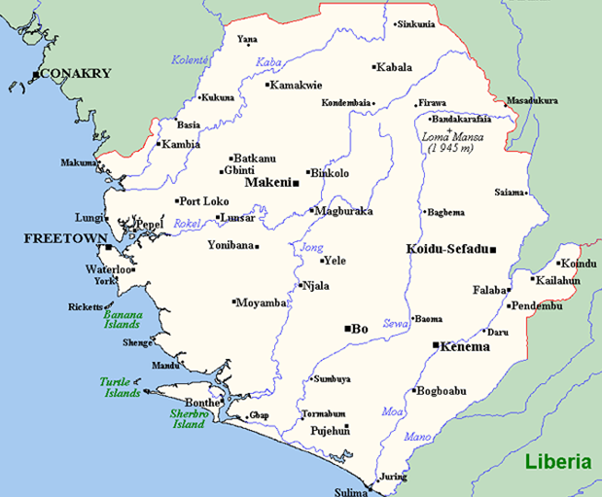
Fig. Map of Sierra Leone after https://upload.wikimedia.org/wikipedia/commons/3/32/SierraLeoneOMC.png
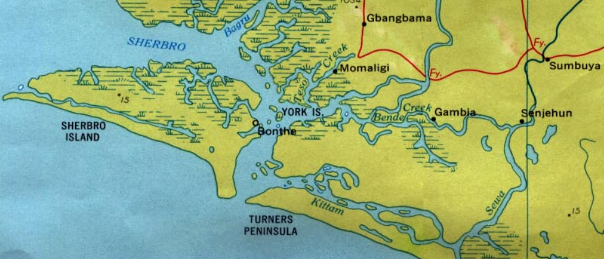
Fig. Map of southernSierra Leone where most nomoli figures have been found after https://upload.wikimedia.org/wikipedia/commons/8/85/Western_Sierra_Leone_1969.jpg
GPS coordinates:
7°18′19″N 12°08′25″W

Cultural Affiliation:
Medium: soapstone
Dimensions: H 17.5 cm
Weight: 2.8 kg
Condition: Old break in the base which seems original. Few small chips also in the ear. Otherwise very fine.
Provenance:
Discussion:
Nomoli continue to play a fairly important part in the life of many older farmers even though their ancient meaning remains unknown. "They are not merely impressed by the grotesqueness of the figure, they are aware of being in the presence of mysterium tremendum and the sense of the numinous ' is aroused. Being charged with this sort of mana the nomoli has to be approached carefully; expectant mothers are forbidden even to look at it. It is not surprising, therefore, that the traditional view that God made these things is easily accepted and all affirm that they are Ngewo gbate hani, i.e. of God's creation '. This does not necessarily mean, however, that He shaped them with His own hands, for here, as in many other of His activities, He is believed to work through the media of spirits (ngafeisia). The real significance of the nomoli is that the one who is fortunate enough to find it has thereby come into possession of a particular and supernatural means of increasing the rice harvest. A large proportion of farmers therefore still covet the possession of a nomoli since it means virtually enslaving the particular spirit who makes their farming successful. Since the nomoli is regarded as being of supernatural origin and as being invested with supernatural power, it follows that the approach must be made in a particular way and that appropriate sacrifices must be made if the ends desired are to be achieved. The figurine is generally kept in a temporary farm shelter and is regularly fed with small portions of the farmer's cooked rice; by its side is a small whip with which it is ceremonially flogged and told to bring plenty of rice; the farmer says : I have boiled rice to-day and have given you your portion; now go and bring plenty for me.' (Ngi mbeiyilia haa, ngi fonya ngi nda bi we, li maa bi wa a nya ndei.)" (Brown 1948: 18).

References:
Atherton, John H. and Milan Kalous. 2009. Nomoli. The Journal of African History, Volume 11, Issue 3, July, pp. 303-317

Brown, Stanley. 1948. The Nomoli of Mende County, Africa: Journal of the International African Institute, 18: 1 (Jan.): 18-20.
G. R. Crone, trans. and ed. 1937. The Voyages of Cadamosto and Other Documents on Western Africa in the Second Half of the Fifteenth Century. London. 87-8. The ' groves of trees' to which Malfante makes reference here are undoubtedly the ' bushes' of the secret societies so common in this part of West Africa.

Rutimeyer, L. 1901. “Ueber westafrikanische Steinidole,” Internationales Archiv für Ethnographie, Band XIV, Heft V, 195-226.
George Thompson, Thompson in Africa, An Account of the Missionary Labours, etc., of George Thompson in Western Africa at the Mendi Mission (New York, 1852), 276

